CS300 SAMPLE FINAL SOLUTIONS

- Given input {4371, 1323, 6173, 4199, 4344, 9679, 1989} and a hash function h(x) = x (mod () 10), show the resulting:

  - separate chaining hash table

On the assumption that we add collisions to the end of the list (which is the easier way if a hash table is being built by hand), the separate chaining hash table that results is shown here.

  - hash table using linear probing

  - hash table using quadratic probing
  - hash table with second hash function h2(x) = 7 − (x mod 7)
1989 cannot be inserted into the table because hash₂(1989) = 6, and the alternative locations 5, 1, 7, and 3 are already taken. The table at this point is as follows:

- Show the result of rehashing the hash tables in Question 1. When rehashing, choose a table size that is roughly twice as large and prime.
When rehashing, we choose a table size that is roughly twice as large and prime. In our case, the appropriate new table size is 19, with hash function h(x) = x(mod 19).
a) Scanning down the separate chaining hash table, the new locations are 4371 in list 1, 1323 in list 12, 6173 in list 17, 4344 in list 12, 4199 in list 0, 9679 in list 8, and 1989 in list 13.
b) The new locations are 9679 in bucket 8, 4371 in bucket 1, 1989 in bucket 13, 1323 in bucket 12, 6173 in bucket 17, 4344 in bucket 14 (because both 12 and 13 are already occupied), and 4199 in bucket 0.
c) The new locations are 9679 in bucket 8, 4371 in bucket 1, 1989 in bucket 13, 1323 in bucket 12, 6173 in bucket 17, 4344 in bucket 16 (because both 12 and 13 are already occupied), and 4199 in bucket 0.
d) The new locations are 9679 in bucket 8, 4371 in bucket 1, 1989 in bucket 13, 1323 in bucket 12, 6173 in bucket 17, 4344 in bucket 15 because 12 is already occupied, and 4199 in bucket 0.
- Instead of linear or quadratic probing, re-implement your HW3 with “cubic probing”; where the i^{th} probe is at hash(x) + i³. Does cubic probing improve on quadratic probing?

// Let's simulate linear, quadratic, and cubic probing.
// Is cubic probing any better than quadratic?
// In this simulation, cells equal to 0 represent empty, and cells
// equal to 1 contain some key value.
#include<iostream>
#include<vector>
#include<cmath>
using namespace std;

const int SIZE = 9001; // prime number over 9,000
const int MAX = 4500;

int main()
{
vector<int>linear(SIZE, -1);
vector<int>quadratic(SIZE,-1);
vector<int>cubic(SIZE,-1);

int linearCollisions = 0;
int quadraticCollisions = 0;
int cubicCollisions = 0;

// We are going to generate random indices to occupy in the hash tables.
srand(0);
for (int i = 0; i < MAX; ++i)
{
int hashCode = rand()% SIZE;
int offset = 0;
while (linear[hashCode] == 1)
{
++linearCollisions;
++offset;
hashCode += offset;
hashCode %= SIZE;
}
linear[hashCode] = 1;
}

srand(0);
for (int i = 0; i < MAX; ++i)
{
int hashCode = rand()% SIZE;
int offset = 0;
while (quadratic[hashCode] == 1)
{
++quadraticCollisions;
++offset;
hashCode += offset * offset;
if (hashCode >= SIZE)
hashCode %= SIZE;
}
quadratic[hashCode] = 1;
}

srand(0);
for (int i = 0; i < MAX; ++i)
{
int hashCode = rand()% SIZE;
int offset = 0;
while (cubic[hashCode] == 1)
{
++cubicCollisions;
++offset;
hashCode += offset * offset * offset;
if (hashCode >= SIZE)
hashCode %= SIZE;
}
cubic[hashCode] = 1;
}

cout<<"Here is the number of collisions for each type of probing.\n";
cout<<"linear = "<<linearCollisions<<endl;
cout<<"quadratic = "<< quadraticCollisions<<endl;
cout<<"cubic = "<< cubicCollisions<<endl;

return 0;
}

- What are the advantages and disadvantages of the various collision resolution strategies?

Separate chaining hashing requires the use of links, which costs some memory, and the standard
method of implementing calls on memory allocation routines, which typically are expensive. Linear probing is easily implemented, but performance degrades severely as the load factor increases because of primary clustering. Quadratic probing is only slightly more difficult to implement and gives good performance in practice. An insertion can fail if the table is half empty, but this is not likely. Even if it were, such an insertion would be so expensive that it wouldn’t matter and would almost certainly point up a weakness in the hash function. Double hashing eliminates primary and secondary clustering, but the computation of a second hash function can be costly. Gonnet and Baeza-Yates compare several hashing strategies; their results suggest that quadratic probing is the fastest method.

- A nonstandard C++ extension adds syntax that allows a switch statement to work with the string type (instead of the primitive integer types). Explain how hash tables can be used by the compiler to implement this language addition.
The compiler could hash each string in the switch statement to a table which holds the starting memory location for the code to be executed for the appropriate string.

- Implement a generic Map that supports the insert and lookup operations. The implementation will store a hash table of pairs (key, definition). You will lookup a definition object by providing a key.

template <typename HashedObj, typename Object>
class Pair
{
public:
Pair(HashedObj k, Object d): key(k), def(d){}
private:
HashedObj key;
Object def;
// Appropriate Constructors, etc.
};

template <typename HashedObj, typename Object>
class Dictionary
{
public:
Dictionary( ) {}
void insert( const HashedObj & key, const Object & definition )
{ items.insert(Pair<HashedObj,Object>(key, definition)); }
const Object & lookup( const HashedObj & key ) const
{ return items.contains(key);}
bool isEmpty( ) const
{ return items.isEmpty(); }
void makeEmpty( )
{ items.makeEmpty(); }
private:
HashTable<Pair<HashedObj,Object> > items;
};

- Show the result of inserting 10, 12, 1, 14, 6, 5, 8, 15, 3, 9, 7, 4, 11, 13, and 2, one at a time, into an initially empty binary heap.
- Show the result of using the linear-time algorithm to build a binary heap using the same input.

a) b)

- Show the result of performing three deleteMin operations in the heap of the
previous exercise.

The result of three deleteMins, starting with both of the heaps in both a and b, is as follows:

- Show the following regarding the maximum item in the heap:
  - It must be at one of the leaves.
Since each element in a min heap has children whose elements are greater than the value in the element itself, the maximum element has no children and is a leaf.

  - Every leaf must be examined to find it.
Since the maximum element can be any leaf (the position of a node is determined entirely by the value of its parent and children), all leaves must be examined to find the maximum value in a min heap.

- Prove that for binary heaps, buildHeap does at most 2N−2 comparisons between elements.

We show that H(N), which is the sum of the heights of nodes in a complete binary tree of N nodes, is N − b(N), where b(N) is the number of ones in the binary representation of N. Observe that for N = 0 and N = 1, the claim is true. Assume that it is true for values of k up to and including N − 1. Suppose the left and right subtrees have L and R nodes, respectively. Since the root has height , we have
The second line follows from the inductive hypothesis, and the third follows because L + R = N − 1. Now the last node in the tree is in either the left subtree or the right subtree. If it is in the left subtree, then the right subtree is a perfect tree, and . Further, the binary representation of N and L are identical, with the exception that the leading 10 in N becomes 1 in L. (For instance, if N = 37 = 100101, L = 10101.) It is clear that the second digit of N must be zero if the last node is in the left subtree. Thus in this case, b(L) = b(N), and
H(N) = N − b(N)
If the last node is in the right subtree, then . The binary representation of R is identical to N, except that the leading 1 is not present. (For instance, if N = 27 = 101011, L = 01011.) Thus b(R) = b(N) − 1, and again
H(N) = N − b(N)

- Give an algorithm to find all nodes less than some value, X, in a binary heap. Your algorithm should run in O(K), where K is the number of nodes output.
Perform a preorder traversal of the heap.

- Suppose we need to perform M percolateUps and N deleteMins on a binary heap that initially has N elements. What is the running time of all of these heap operations?
O((M + N) log N)

- Show the result of the following sequence of union instructions on trees representing disjoint sets: union(1,2), union(3,4), union(3,5), union(1,7), union(3,6), union(8,9), union(1,8), union(3,10), union (3,11), union(3,12), union(3,13), union(14,15), union(16,0), union(14,16), union (1,3), union(1, 14) when the unions are:
  - performed arbitrarily
  - performed by height
  - performed by size

We assume that unions operated on the roots of the trees containing the arguments. Also, in case of ties, the second tree is made a child of the first. Arbitrary union and union by height give the same answer (shown as the first tree) for this problem. Union by size gives the second tree.

- For each of the trees in the previous question 12, perform a find with path compression on the deepest node.

In both cases, have nodes 16 and 0 point directly to the root.

- Show that if unions are performed by height, then the depth of any tree is O(logN).

Claim: A tree of height h has at least 2^{h} nodes. The proof is by induction. A tree of height 0 clearly has at least 1 node, and a tree of height 1 clearly has at least 2. Let T be the tree of height h with fewest nodes. Thus at the time of T’s last union, it must have been a tree of height h − 1, since otherwise T would have been smaller at that time than it is now and still would have been of height h, which is impossible by assumption of T’s minimality. Since T’s height was updated, it must have been as a result of a union with another tree of height h − 1. By the induction hypothesis, we know that at the time of the union, T had at least 2^{h−1} nodes, as did the tree attached to it, for a total of 2^{h} nodes, proving the claim. Thus an N-node tree has depth at most .

- Suppose f (n) is a nicely defined function that reduces n to a smaller integer. What is the solution to the recurrence T(N) = n/f (n)*T(f (n)) + n with appropriate initial conditions?
We are given T(n) = n/f(n) * T(f(n)) + n

First, we expand T(f(n)) using the definition of T(n) itself:
T(f(n)) = f(n)/f(f(n)) * T(f(f(n))) + n
and then substitute this expression for T(f(n)) into the original formula to obtain
T(n) = n/f(n) * [ f(n)/f(f(n)) * T(f(f(n))) + n ] + n
= n/f(f(n)) * T(f(f(n)) + n²/f(n) + n
Next, we consider T(f(f(n)). We expand this term next:
T(f(f(n))) = f(f(n))/f(f(f(n))) * T(f(f(f(n)))) + n
and then substitute this expression for T(f(f(n))) into the most recent formula we have for T(n).
T(n) = n/f(f(n)) * [ f(f(n))/f(f(f(n))) * T(f(f(f(n)))) + n ] + n²/f(n) + n
= n/f(f(f(n))) * T(f(f(f(n))) + n²/f(f(n)) + n²/f(n) + n
And, next we expand T(f(f(f(n)))) using the definition of T.
T(f(f(f(n)))) = f(f(f(n)))/f(f(f(f(n)))) * T(f(f(f(f(n))))) + n
and let's substitute into the most recent formula for T.
T(n) = n/f(f(f(n))) * [ f(f(f(n)))/f(f(f(f(n)))) * T(f(f(f(f(n))))) + n] + n²/f(f(n)) + n²/f(n) + n
= n/f(f(f(f(n)))) * T(f(f(f(f(n))))) + n²/f(f(f(n))) + n²/f(f(n)) + n²/f(n) + n
= n/f(f(f(f(n)))) * T(f(f(f(f(n))))) + n²[1/f(f(f(n)))+1/f(f(n))+1/f(n)] + n
And in general, this can go on indefinitely, and we would obtain
T(n) = n/f ^{k}(n) * T(f^{k}(n)) + n²[1/f ^{k–1}(n)+1/f ^{k–2}(n)+...+1/f(n)] + n
And eventually, f^{k}(n) = 1, so our equation becomes T(n) = n * T(1) + n²[sum of small fractions] + n.
Let's assume the sum in brackets equals s. We obtain: T(n) = n * T(1) + s*n² + n.
We need to assume an initial condition for T(1). Let us assume it is c. Now we have T(n) = cn + s*n² + n = s*n² + (c+1)n. In other words, T(n) is a polynomial of degree 2, or T(n) = O(n²).

- Sort the sequence 3, 1, 4, 1, 5, 9, 2, 6, 5 using insertion sort. Show each step.

- What is the running time of insertion sort if all elements are equal?
O(N), because the while loop terminates immediately. Of course, accidentally changing the test to include equalities raises the running time to quadratic for this type of input.

- What is the running time of Shellsort using the two-increment sequence {1, 2}?

Θ(N²). The 2-sort removes at most only three inversions at a time; hence the algorithm is Ω(N²). The 2-sort is two insertion sorts of size N/2, so the cost of that pass is O(N²). The 1-sort is also O(N²), so the total is O(N²).

- Show how heapsort processes the input 142, 543, 123, 65, 453, 879, 572, 434,111, 242, 811, 102.
The input is read in as
142, 543, 123, 65, 453, 879, 572, 434, 111, 242, 811, 102
The result of the heapify is
879, 811, 572, 434, 543, 123, 142, 65, 111, 242, 453, 102
879 is removed from the heap and placed at the end. We’ll place it in italics to signal that it is not part of the heap. 102 is placed in the hole and bubbled down, obtaining
811, 543, 572, 434, 453, 123, 142, 65, 111, 242, 102, 879
Continuing the process, we obtain
572, 543, 142, 434, 453, 123, 102, 65, 111, 242, 811, 879
543, 453, 142, 434, 242, 123, 102, 65, 111, 572, 811, 879
453, 434, 142, 111, 242, 123, 102, 65, 543, 572, 811, 879
434, 242, 142, 111, 65, 123, 102, 453, 543, 572, 811, 879
242, 111, 142, 102, 65, 123, 434, 453, 543, 572, 811, 879
142, 111, 123, 102, 65, 242, 434, 453, 543, 572, 811, 879
123, 111, 65, 102, 142, 242, 434, 453, 543, 572, 811, 879
111, 102, 65, 123, 142, 242, 434, 453, 543, 572, 811, 879
102, 65, 111, 123, 142, 242, 434, 453, 543, 572, 811, 879
65, 102, 111, 123, 142, 242, 434, 453, 543, 572, 811, 879

- What is the running time of heapsort for presorted input?
O(N log N)

- Sort { 3, 1, 4, 1, 5, 9, 2, 6 } using mergesort. Show each step.

First the sequence {3, 1, 4, 1} is sorted. To do this, the sequence {3, 1} is sorted. This involves sorting {3} and {1}, which are base cases, and merging the result to obtain {1, 3}. The sequence {4, 1} is likewise sorted into {1, 4}. Then these two sequences are merged to obtain {1, 1, 3, 4}. The second half is sorted similarly, eventually obtaining {2, 5, 6, 9}. The merged result is then easily computed as {1, 1, 2, 3, 4, 5, 6, 9}.

- Determine the running time of mergesort for
  - sorted input
  - reverse-ordered input
  - random input

The merging step always takes Θ(N) time, so the sorting process takes Θ(N log N) time on all inputs.

- Sort 3, 1, 4, 1, 5, 9, 2, 6, 5, 3, 5 using quicksort with median-of-three partitioning and a cutoff of 3.

The original input is
3, 1, 4, 1, 5, 9, 2, 6, 5, 3, 5
After sorting the first, middle, and last elements, we have
3, 1, 4, 1, 5, 5, 2, 6, 5, 3, 9
Thus the pivot is 5. Hiding it gives
3, 1, 4, 1, 5, 3, 2, 6, 5, 5, 9
The first swap is between two fives. The next swap has i and j crossing. Thus the pivot is swapped back with i:
3, 1, 4, 1, 5, 3, 2, 5, 5, 6, 9
We now recursively quicksort the first eight elements:
3, 1, 4, 1, 5, 3, 2, 5
Sorting the three appropriate elements gives
1, 1, 4, 3, 5, 3, 2, 5
Thus the pivot is 3, which gets hidden:
1, 1, 4, 2, 5, 3, 3, 5
The first swap is between 4 and 3:
1, 1, 3, 2, 5, 4, 3, 5
The next swap crosses pointers, so is undone; i points at 5, and so the pivot is swapped:
1, 1, 3, 2, 3, 4, 5, 5
A recursive call is now made to sort the first four elements. The pivot is 1, and the partition does not make any changes. The recursive calls are made, but the subfiles are below the cutoff, so nothing is done. Likewise, the last three elements constitute a base case, so nothing is done. We return to the original call, which now calls quicksort recursively on the right-hand side, but again, there are only three elements, so nothing is done. The result is
1, 1, 3, 2, 3, 4, 5, 5, 5, 6, 9
which is cleaned up by insertion sort.

- Write the recurrence T(N) for the average case of quicksort and solve it.
T(0) = 0
T(N) = (1/N) [$\sum_{i=0}^{N-1}{T(i)}$ ] + cN,
See slides.

- Using the quicksort implementation in this chapter, determine the running time of quicksort for
  - sorted input
O(N log N) because the pivot will partition perfectly.

  - reverse-ordered input
Again, O(N log N) because the pivot will partition perfectly.

  - random input
O(N log N); the performance is slightly better than the analysis suggests because of the median-of-three partition and cutoff.

- Repeat Question 25 when the pivot is chosen as:
  - the first element
If the first element is chosen as the pivot, the running time degenerates to quadratic in the first two cases. It is still O(N log N) for random input.

  - the larger of the first two distinct elements
The same results apply for this pivot choice.
  - a random element
If a random element is chosen, then the running time is O(N log N) expected for all inputs, although there is an O(N²) worst case if very bad random numbers come up. There is, however, an essentially negligible chance of this occurring. Chapter 10 of your textbook discusses the randomized philosophy.

  - the average of all elements in the set
This is a dangerous road to go; it depends on the distribution of the keys. For many distributions, such as uniform, the performance is O(N log N) on average. For a skewed distribution, such as with the input {1, 2, 4, 8, 16, 32, 64, . . . ,} the pivot will be consistently terrible, giving quadratic running time, independent of the ordering of the input.

- Construct a permutation of 20 elements that is as bad as possible for quicksort using median-of-three partitioning and a cutoff of 3.

The strategy used here is to force the worst possible pivot at each stage. This doesn’t necessarily give the maximum amount of work (since there are few exchanges, just lots of comparisons), but it does give Ω(N²) comparisons. By working backward, we can arrive at the following permutation:
20, 3, 5, 7, 9, 11, 13, 15, 17, 19, 4, 10, 2, 12, 6, 14, 1, 16, 8, 18
A method to extend this to larger numbers when N is even is as follows: The first element is N, the middle is N − 1, and the last is N − 2. Odd numbers (except 1) are written in decreasing order starting to the left of center. Even numbers are written in decreasing order by starting at the rightmost spot, always skipping one available empty slot, and wrapping around when the center is reached. This method takes O(N log N) time to generate the permutation, but is suitable for a hand calculation. By inverting the actions of quicksort, it is possible to generate the permutation in linear time.
- Find a topological ordering for the graph below:

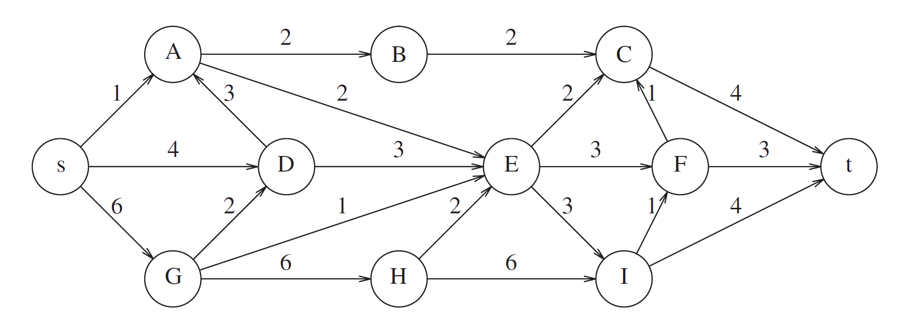

  - Use a queue and assume that vertices appear on an adjacency list alphabetically.
The topological order that results is then
s, G, D, H, A, B, E, I, F, C, t

  - Use a stack and assume that vertices appear on an adjacency list alphabetically.
s, G, H, D, A, E, I, F, B, C, t
Because a topological sort processes vertices in the same manner as a breadth-first search, it tends to produce a more natural ordering.

- Find the shortest path from A to all other vertices for the graph below, show your steps:

A → C, A → B, A → B → G, A → B → G → E, A → B → G → E → F, A → B → G → E → D

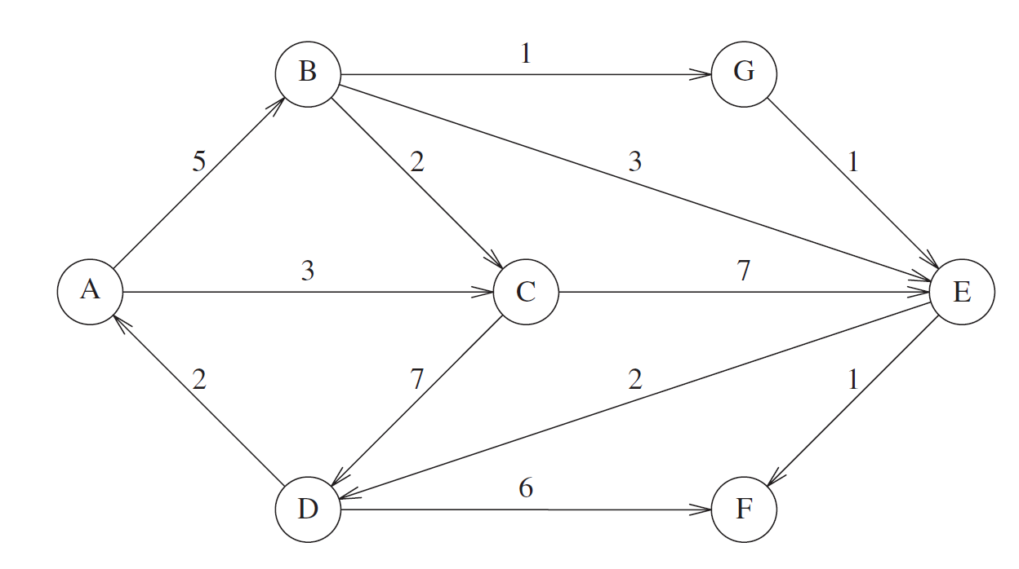

- Find a minimum spanning tree for the graph below using Prim’s algorithm.
Is this minimum spanning tree unique? Why?

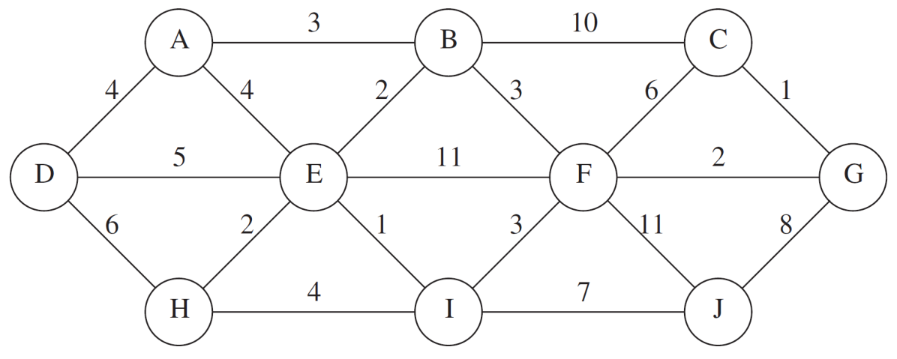

One possible minimum spanning tree is shown here. This solution is not unique.

- Write a program to implement Kruskal’s algorithm.

/*
Finds the min weight spanning tree for a weighted graph stored as adjacency list
Assumes vertex labels are integers from 0 to |V| -1
input format:
The first line contains the number of vertices n
Each of the next n lines starts with the outdegree of that vertex (m) followed by m
label, edge weight pairs.

output is a list of edges given by the 2 vertices.
*/
#include<iostream>
#include<vector>
#include <queue>
using namespace std;

class DisjointSet
{
private:
vector<int> set;
public:
DisjointSet(int size= 0) : set(size,-1) {}
int find(int i)
{
if (set[i] < 0) return i;
else return set[i] = find(set[i]);
}
void setUnion(int a, int b)
{
int setA = find(a);
int setB = find(b);
if (setA != setB) {
if (set[setA] < set[setB]) {
set[setA] += set[setB];
set[setB] = setA;
}
else {
set[setB] += set[setA];
set[setA] = setB;
}
}
}
};

struct Vertex
{
int label;
bool known;
vector<double> weight;
vector<int> adj;
Vertex (int name=-1) {label = name; known = false;}
};

struct Edge
{
int fromVert;
int toVert;
double weight;
Edge (int from=-1, int to=-1, double w = -1):fromVert(from), toVert(to), weight(w)
{}
bool operator< (const Edge & rhs) const
{ return weight > rhs.weight; }
};

class Graph
{
private:
vector<Vertex> adjList;
priority_queue<Edge> edges;
public:
Graph() {}
void insert(Vertex V) {
adjList.push_back(V);
}
vector<Edge> kruskal()
{
DisjointSet sets(adjList.size());
vector<Edge> tree;
int a, b;
tree.push_back(edges.top());
sets.setUnion(edges.top().fromVert, edges.top().toVert);
edges.pop();
while (!edges.empty() && tree.size() < adjList.size()) {
if (sets.find(a=edges.top().toVert) !=sets.find(b=edges.top().fromVert)) {
sets.setUnion(a,b);
tree.push_back(edges.top());
}
edges.pop();
}
return tree;
}

void readIn()
{
int numVerts; int outDegree;
int adjLabel; double weight;
Vertex vertex; Edge edge;
cin >> numVerts;
for (int i = 0; i < numVerts; i++)
{
cin>>outDegree;
vertex.label = i;
for (int j = 0; j<outDegree; j++) {
cin>>adjLabel;
vertex.adj.push_back(adjLabel);
cin>>weight;
vertex.weight.push_back(weight);
edge.fromVert = i;
edge.toVert = adjLabel;
edge.weight = weight;
edges.push(edge);
}
insert(vertex);
vertex.adj.clear();
vertex.weight.clear();
}
}
};
int main()
{
Graph graph;
vector<Edge> spanTree;

graph.readIn();
spanTree =graph.kruskal();
for (int i = 0; i < spanTree.size(); i++)
cout <<spanTree[i].fromVert<<" "<<spanTree[i].toVert
<<" "<<spanTree[i].weight<<endl;
return 0;
}

- Give an algorithm to decide whether an edge (v, w) in a depth-first spanning forest of a directed graph is a tree, back, cross, or forward edge.

Suppose the vertices are numbered in preorder and postorder.
If (v, w) is a tree edge, then v must have a smaller preorder number than w. It is easy to see that the converse is true.
If (v, w) is a cross edge, then v must have both a larger preorder and postorder number than w. The converse is shown as follows: Because v has a larger preorder number, w cannot be a descendent of v; because it has a larger postorder number, v cannot be a descendent of w; thus they must be in different trees.
Otherwise, v has a larger preorder number but is not a cross edge. To test if (v, w) is a back edge, keep a stack of vertices that are active in the depth-first search call (that is, a stack of vertices on the path from the current root). By keeping a bit array indicating presence on the stack, we can easily decide if (v, w) is a back edge or a forward edge.

